**Document Contributors:**

Gabe Venegas

Dominic Holsinger

Sarvarbek Soporboev

Omar Ayssar Borham

Ramses Del Mar Garavito

**SIE 277 Semester Project Micro Lab 1**

**Sections:**

* Team Contacts
* Team Roles
* Signed Commitment Pledge
* Signed Commitment Pledge (Signatures)
* Initial Understanding of System
* Initial Requirements and Use Cases
* Team Meeting Notes (9/24)

**Team Contacts**

| **Name** | **Email** | **Discord** |
| --- | --- | --- |
| Gabe Venegas | venegasg1@arizona.edu | sneupi |
| Dominic Holsinger | domholsinger@arizona.edu | argonautx |
| Sarvarbek Soporboev | sarvarsoporboyev@arizona.edu | sarvarsoporboyev |
| Omar Ayssar Borham | oborham@arizona.edu | oborham |
| Ramses Del Mar Garavito | rgaravito@arizona.edu | ramsesg |

**Team Roles**

These may and should change over time. Remember: although you may be responsible for sections, phases, or submissions, every group member must contribute to every effort and task. Required.

| **Member** | **Role** | **Specialized Responsibilities** |
| --- | --- | --- |
| Gabe Venegas | Flexible/Coordinator | Able to complete any tasks as delegated. Able to coordinate documents or meetings (if need be). |
| Dominc Holsinger | Flexible/Secretary | Records the discussion and main points during meetings with the group. Able to complete any tasks as delegated. |
| Sarvarbek Soporboev | Flexible/Use Case Development | Create detailed use case diagrams and use case specifications that outline system functionality from a user's perspective. Identify actors, scenarios, and system interactions. Able to complete any tasks as delegated. |
| Omar Ayssar Borham | Flexible | Able to complete any tasks as delegated. |
| Ramses Del Mar Garavito | Flexible | Able to complete any tasks as delegated. |

**Signed Commitment Pledge**

* **Meeting Time:**
  + **[TENTATIVE] Sunday @ 12-2pm (via Discord)**
* *Team Execution Plan:*
* Responsibilities of each team member will be completed within 48 hours of each respective due date. This is to allow at least one day to talk, and one day to fix any conflicts that may occur.
* We will be utilizing a private team Discord server for team meetings, where all meetings will be documented by our team secretary in notes.
* Google Drive will be used for coordination of files.
* *Team Communication:*
* 10 hours will be the expected turnaround time for messages.
* Majority of work will be performed remotely, and at our own individual paces (within constraint of the due dates).
* Meeting times will be utilized to put everyone on the same page, to be aware of individual tasks before each next subsequent meeting.
* *Plan for Resolution of Team Dynamic Issues*
* Teammates will attempt to individually work out discrepancies among related members, and relay all updates/information to the group. If a conflict is not hashed out on a group level, the conflict will be escalated to the professor(s) of the class/project.
* *Code of Academic Integrity commitment*
  + All team members agree to treat all generated work as proprietary intellectual property, which shall not be shared under any circumstances among other SIE 277 groups.

**Signed Commitment Pledge (Signatures)**

*Gabe Venegas*

*Dominic Holsinger*

*Sarvarbek Soporboev*

*Ramses Garavito*

*Omar Borham*

**Initial Understanding of System**

Together, you will build a less than one-page blended understanding of the system you are about to design. Please include notes of ideas you have beyond the initial requirements. You may abandon these later, but having a brainstorm session early on opens your minds to the possibilities and opportunities ahead of you.

The system is a Social Media Reputation Management System (SMRMS). The system is an open-source software system that is developed to assist organizations and brands with managing their reputation across all of their social media platforms they own. The system is a central hub for organizations’ accounts to analyze the public’s perception of their brand so they may make informed decisions to generate a more positive response, or to maintain their approach to continue their actions to maintain their reputation.

From the System Overview document provided, **it is assumed** that the SMRMS is intended to be used by one brand or organization at a time, and not intended for managing, tracking, and recording analytics for multiple brands/organizations in a single cloud-hosted instance of the SMRMS. One SMRMS instance per one brand/organization.

**Initial Requirements and Use Cases**

Together, you will build a short list of Functional and Non-Functional requirements based on both the overview document and what you discussed during your brainstorm. While there is no limit to the number of these you may submit during this round (Micro Lab 1) you should have at least three of each type.

Once again, you may change your mind about these requirements and use cases later. Please submit well-formed requirements statements and a hand-drawn use case diagram and use case specification for at least three of the Functional Requirements.

| **Use Case:** RegisterUser |
| --- |
| **ID:** 1 |
| **Brief Description:** The user shall create an account with a unique username, password, and display name. |
| **Primary Actor:** User |
| **Secondary Actors:** None |
| **Precondition:** None |
| **Main Flow:**   1. The use case begins when the user presses the register new account button 2. The user will be taken to the registration screen 3. The user will input a username 4. The user will input a password and confirm password 5. The user will input the display name they wish to have 6. The user will then click the register button and their account will be added to the database. 7. The use case has ended. |
| **Post Condition:** The user’s username, password, and display name are all added to the database. |
| **Alternative Flow:**   1. If the entered username is not unique and is already in use by another user, the system displays an error message indicating that the chosen username is unavailable. 2. The user is prompted to enter a different username. 3. The user repeats the username entry process and submits a unique username. 4. The system proceeds with the registration process from the appropriate step of the main flow. 5. The user’s entered password does not meet the requirements for a strong password, therefore an error message is displayed. 6. The user shall enter a password that at minimum contains 8 characters, one upper case letter, one lower case letter, one number, one special character 7. The user shall repeat the process until the password is accepted, and the system proceeds with the registration process from the appropriate step of the main flow 8. The user has entered a non-matching password from the confirm password field and is warned the passwords do not match 9. The user must retype the password until the passwords match in both fields 10. The system proceeds with the registration process from the appropriate step of the main flow |

| **Use Case:** LoginUser |
| --- |
| **ID:** 2 |
| **Brief Description:** A user shall have the capability to login to the SMRMS system using an existing system username and password combination. |
| **Primary Actor:** User |
| **Secondary Actors:** None |
| **Precondition:** The user must have a registered account within the system |
| **Main Flow:**   1. The use case begins when the User is prompted to login. 2. The User will enter their username 3. The user will enter their password. 4. The User’s input will be authenticated by the UMS subsystem. 5. The system will log the User into the system. 6. The use case has ended. |
| **Post Condition:** The system menu will update to display appropriate system features, relative to the User’s system authorization level. |
| **Alternative Flow:**   1. If the entered username is not in the database, the user will be warned that that username is not registered 2. The user is prompted to enter a username that is already registered 3. The system proceeds with the login process from the appropriate step of the main flow 4. If the entered password is not connected to the entered username, the user will be warned the password is incorrect 5. The user is prompted to enter the correct password for the entered username 6. The system proceeds with the login process from the appropriate step of the main flow |

| **Use Case:** SelectPlatform |
| --- |
| **ID:** 3 |
| **Brief Description:** An authorized system user shall be capable of setting up the SMRMS system selecting a social media API that will be used by the SMRMS. |
| **Primary Actor:** Admin |
| **Secondary Actors:** |
| **Precondition:**The authorized user has successfully logged into the SMRMS.  The user has administrative privileges or settings access. The organization has connected at least one social media platform to the SMRMS. |
| **Main Flow:**   1. The use case begins when an authorized user accesses the system's configuration or settings page. 2. The system displays the "Configure Social Media APIs" section within the settings interface. 3. The user reviews a list of available social media APIs, each representing a different social media platform, such as Facebook, Twitter, Instagram, and others. 4. For each API, the user performs the following actions: 5. a. Selects the API by checking a checkbox or taking the appropriate action as per the system's interface design to indicate their intention to use it. 6. b. Deselects the API to indicate they do not want the SMRMS to use data from that specific social media platform. 7. The user confirms their API selection and deselection choices. 8. The system updates the SMRMS configuration based on the user's selections, enabling or disabling data retrieval and processing for the selected social media APIs. 9. The system displays a confirmation message to the user, indicating that the configuration changes have been saved successfully. 10. The use case has ended. |
| **Post Condition:**The SMRMS system is configured to use the selected social media APIs as specified by the authorized user. |
| **Alternative Flow:**   1. In case of technical issues, such as server unavailability or issues with the configuration update process, the system may display an error message indicating that the configuration changes cannot be saved at the moment. 2. The user is advised to try again later, and the system logs the error for technical support investigation. |

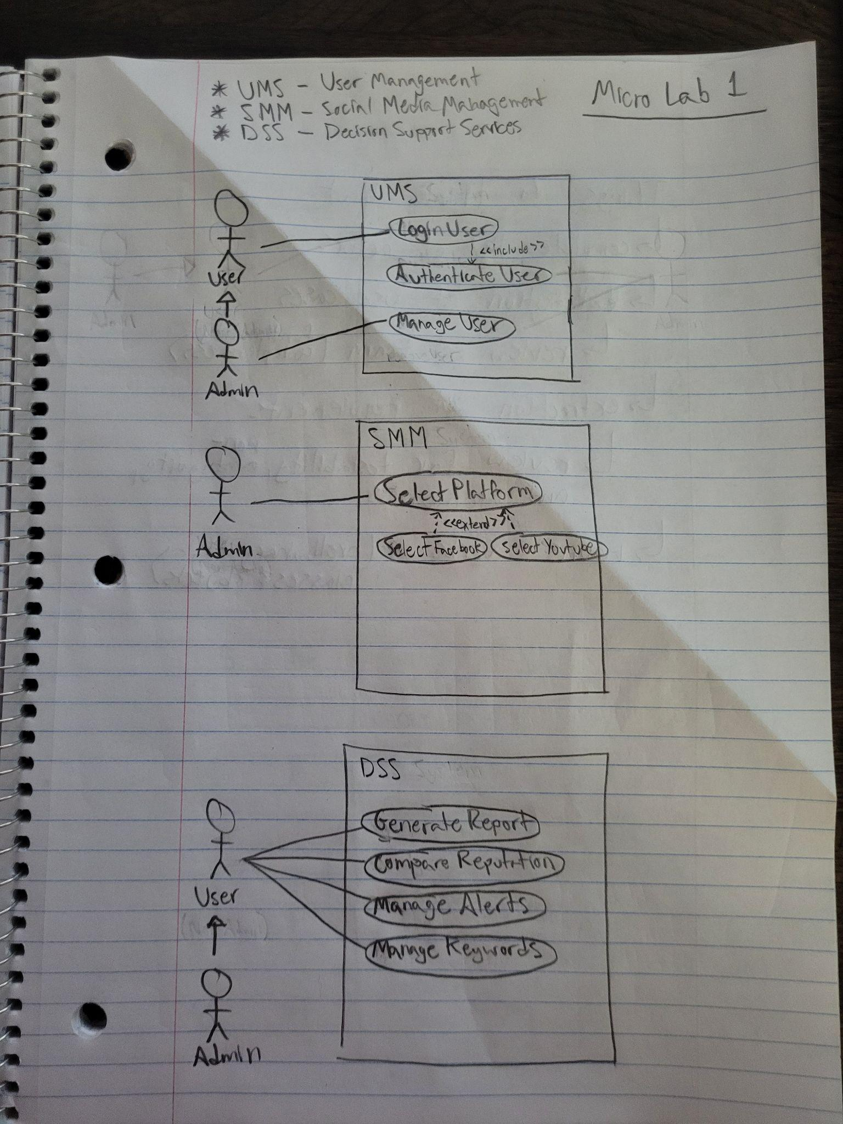

**\*Note:** NF=Non-Functional, F=Functional

| ID | Type | Requirements |
| --- | --- | --- |
| 1 | NF | The SMRMS System shall be implemented strictly using open-source software development. |
| 2 | NF | The SMRMS system DSS subsystem predictive tools shall yield predictions that are >=50% accuracy. |
| 3 | NF | The SMRMS system shall employ security and privacy standards in accordance with the Federal Communications Commission (FCC). |
| 4 | F | The SMRMS system shall provide the capability to authorize system admins to manage, create, or remove system users. |
| 5 | NF | The SMRMS system UMS subsystem shall allow admins to only modify, create, or remove users who are of lower SMRMS system authority level. |
| 6 | NF | The SMRMS system DSS subsystem shall provide the capability for generating reports using analytics gathered from user-set social media accounts, using each respective social platform APIs. |
| 7 | NF | The SMRMS system DSS subsystem shall provide the capability for sending alerts externally via Email to users. |
| 8 | F | The SMRMS system DSS subsystem shall provide the capability for sending alerts to users. |
| 9 | NF | The SMRMS system DSS subsystem shall disburse alerts as frequently as scheduled by the respective user. |

**Team Meeting Notes (9/24):**

We agreed on a (tentative) time to meet as a group.

We agreed virtual meetings at least once a week.

We collaborated on creating a document for the Micro lab 1.

We typed up the functional and non-functional requirements that we have, as well as creating the use case specifications.

Created the initial understanding of the system.

We agreed SMRMS usage corresponds 1-1 for one brand per oneSMRMS instance.

Assigned team roles.

Created the commitment pledge, including how often we will meet and the effort to be put into each task.

Attendance:

Dom, Gabe, Sarvarbek

Absence:

Omar (emergency), Ramses (medical emergency)